**DRAFT Version**

1. Configure Data Dictionary
   1. Options for ‘Configure Data Dictionary’

The menu-item for configuring the data-dictionary has been provided under the OS 2200 Menu. The user would have to click this option to launch the Configure Data-Dictionary window.

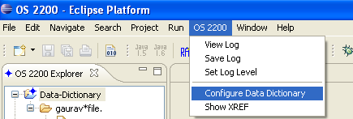

* 1. Default values

For the first-time, the Configure Data-Dictionary window would show the following values as defaults:

Files Location <loc>: \\SQMRSCENTRON001\NTSYSREF

MRP List File : <loc>\sqm\data\cobedit\standard\mrplist.ini

Data Dictionary Doc: <loc>\sqm\mdb\datadict\<mrph>doc*.txt

Standard Offsets and XREF: <loc>\sqm\mdb\datadict\<mrph>fld*.txt

* 1. Configuring the Data Dictionary

If the MRP List File is not found for some reason, the text-boxes for ‘Data Dictionary Doc’ and ‘Standard Offsets and XREF’ would be disabled as shown in the following screenshot.

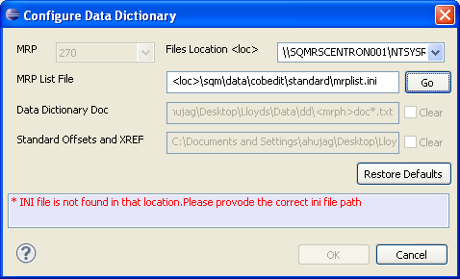

The user would have to provide the correct-path for the MRP List File and click ‘Go’ button provided to the right-hand-side of the designated text-box. Once this path is verified, the user would be shown the MRP-list in the MRP drop-down box and the text-boxes for ‘Data Dictionary Doc’ and ‘Standard Offsets and XREF’ would be enabled, as shown below:

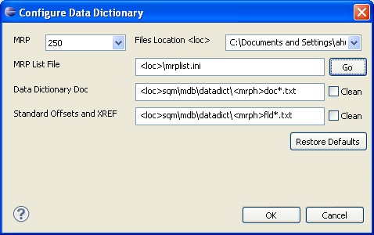

Now, the user may press OK button in order to configure the Data-Dictionary and Offsets-File. In case any or both of these files (Data-Dictionary and Offsets-file) is unavailable at the destination-path, the user would be shown the following error-message:

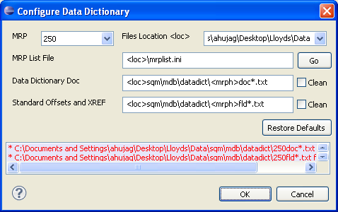

The user would have to provide the correct path for these files and click OK. If the process is clean, no message would be shown to the user and the above window would dispose.

* 1. Views for Data Dictionary and Standard Offsets files

The successful completion of Data-Dictionary configuration would populate two views automatically, namely Data-Dictionary View and XREF View:

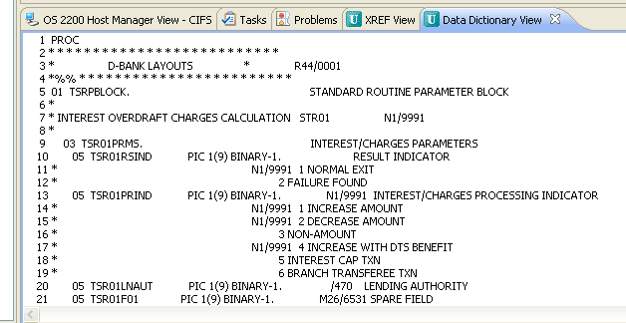

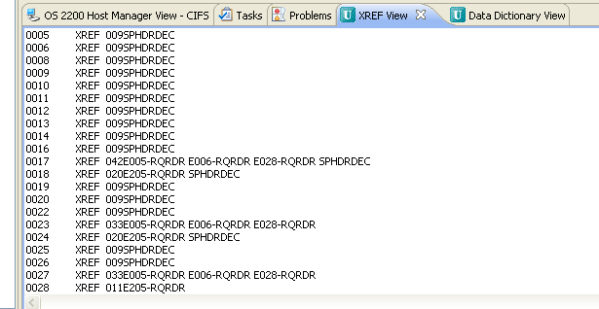

These views would show the complete Data-Dictionary and Offsets & XREF file.

* 1. Re-Configuring the Data Dictionary and Offset-file

If the user wants to re-run the configuration again, he may do it for the following two scenarios:

* + 1. The MRP number has to be changed, i.e. the user wants to configure a new or an old version of Data-Dictionary and Offset-File. In this case, the user has to select the new version-number in the MRP drop-down box and click OK button. The new files would be configured and ready for use:

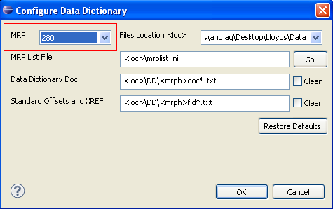

* + 1. The user may choose to re-configure the same Data-Dictionary and Offset-File. In this case, the user would have to select the ‘Clean’ check-boxes provided for Data-Dictionary and Offset-File. The user may choose to ‘Clean’ any or both of the configurations at a time.

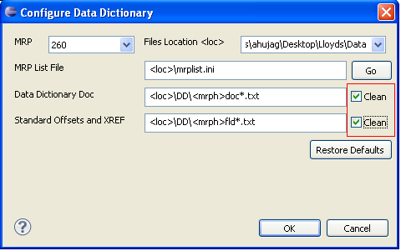

* 1. Tool-tip

The configuration is successful and the user can now refer any variable declared in the Data-Dictionary in any program opened in the COBOL editor:

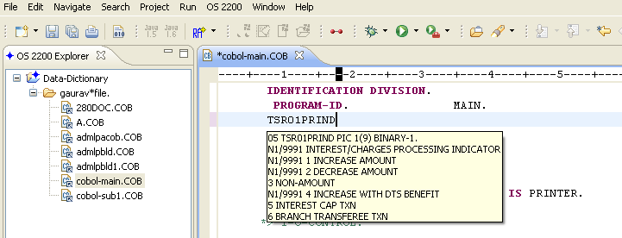

The tool-tip would be shown when the mouse hovers over the variable-name that exists in the Data-Dictionary. Tool-tip would be shown irrespective of the Division in the COBOL program. As can be seen in the above screenshot, the variable-name existed just after the Identification Division.

* 1. Content-Assist

The content-assist would work for these variables only in the Procedure Division of the COBOL program opened in the COBOL Editor in Eclipse:

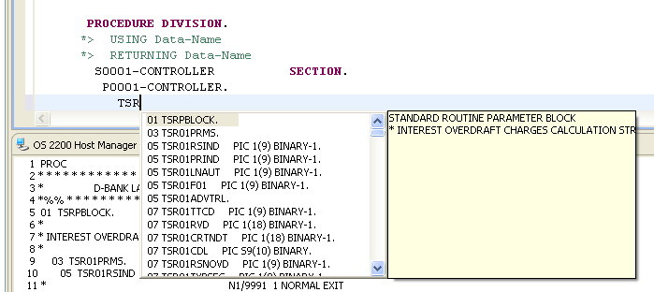

The content-assist would enlist the variables from the Data-Dictionary only when the user keys in at least 3 alphabets. In the screenshot shown above, the user has keyed in ‘TSR’ in order to list out all the variables that start with TSR from the Data-Dictionary as well as the Working-Storage Section in the program.

* 1. Context Menu for ‘Show in XREF view’ and ‘Show in Data Dictionary view’

The user would have to select the variable-name from the content-assist window and transmit to insert that variable-name in the program. Alternatively, he can double-click the variable-declaration in the content-assist window to insert its name. Once the variable-name from the Data-Dictionary has been inserted over the editor, the user can select it by dragging the mouse over it or double-clicking it. Once selected, the user can right-click this variable. The context-menu would show three options that are relevant to this feature:

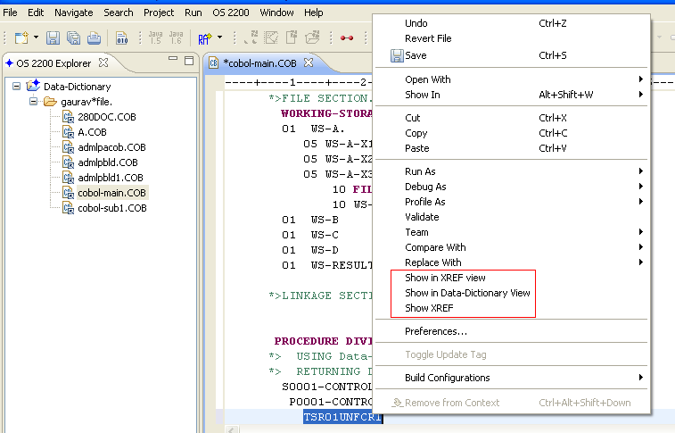

Option: Show in XREF view

When clicked over this option, the entry for this variable-name would be shown to the user in the XREF view:

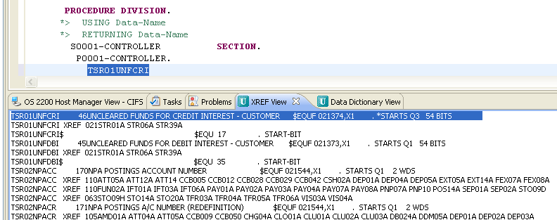

Option: Show in Data Dictionary view

When clicked over this option, the entry for this variable-name would be shown to the user in the Data Dictionary view:

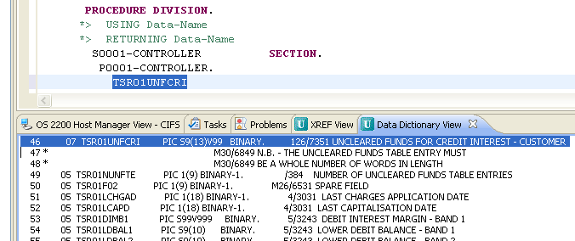

1. Show XREF
   1. Context Menu for ‘Show XREF’

The user can refer to the XREF-information for a variable using the 3rd option in the context-menu, i.e.

Option: Show XREF

When clicked over this option, a new ‘Show XREF’ window would pop-up with the variable-name already filled and its XREF information displayed:

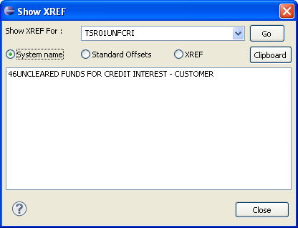

The user may choose any of the 3 radio-buttons in order to view the desired information:

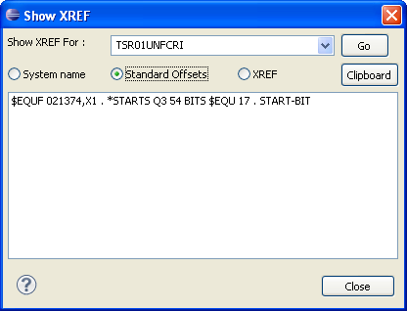

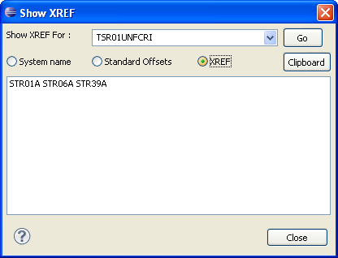

If the user selects the information provided in the box, the user would be shown that variable-information in the XREF view:

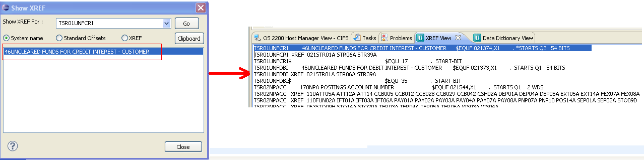

* 1. OS 2200 menu for ‘Show XREF’

The user may select the variable-name over the editor and select ‘Show XREF’ from the OS 2200 menu provided in the menu-bar:

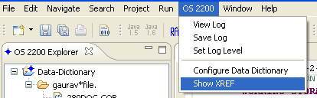

If the variable-name is not selected and the user chooses the option for ‘Show XREF’ from the context-menu or the OS 2200 menu, the user would be shown a blank window:

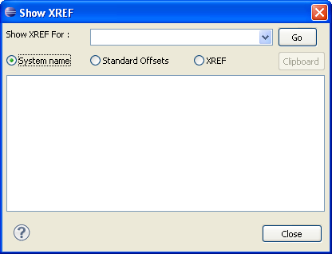

The user may select a variable-name from the drop-down list in the ‘Show XREF For:’ drop-down box. This option would let the user choose a variable from last 10 entries:

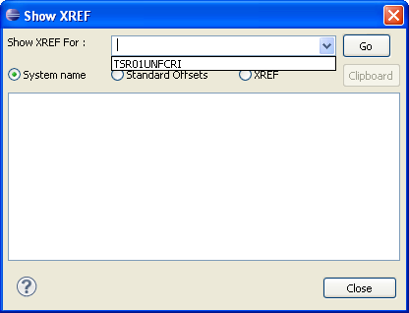

The user can key-in a variable-name and click ‘Go’ button in order to display the XREF-information:

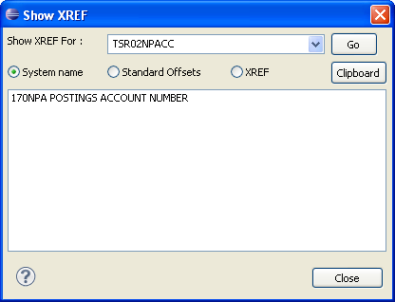

The ‘Clipboard’ button may be used to copy the information that is being displayed in the result-box to the clipboard. A normal ‘Paste’ or ‘CTRL + V’ can be used to paste this information over any editor.